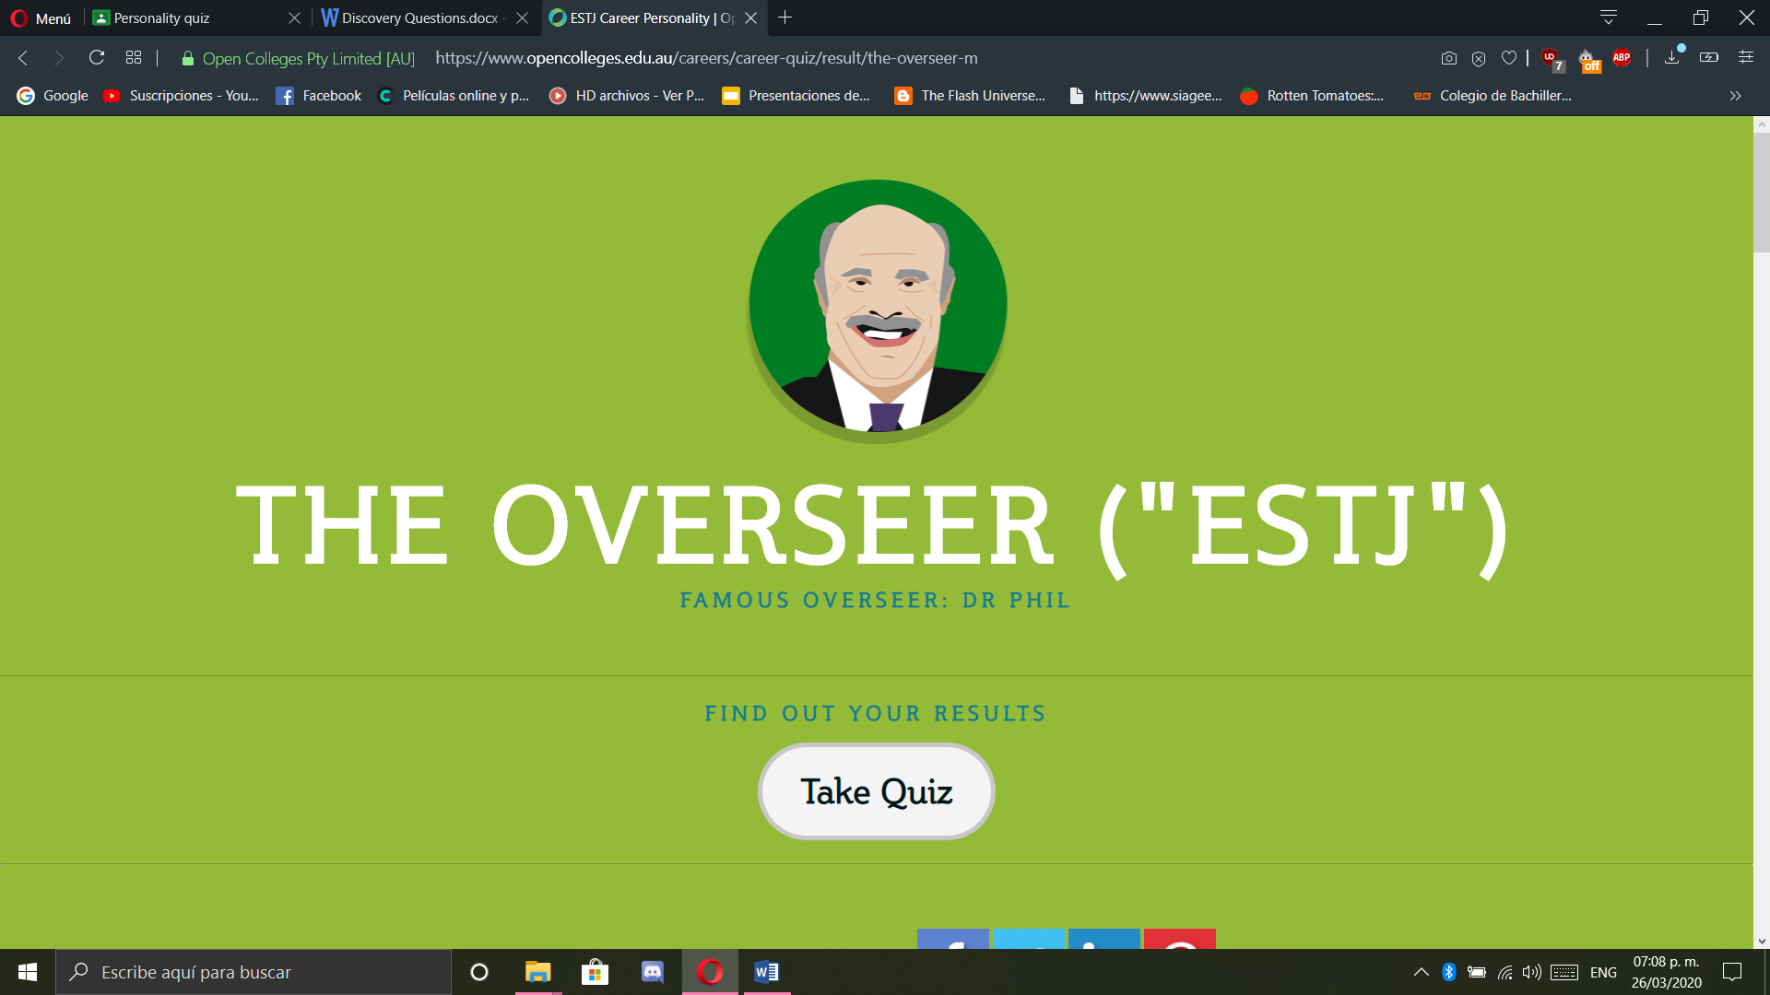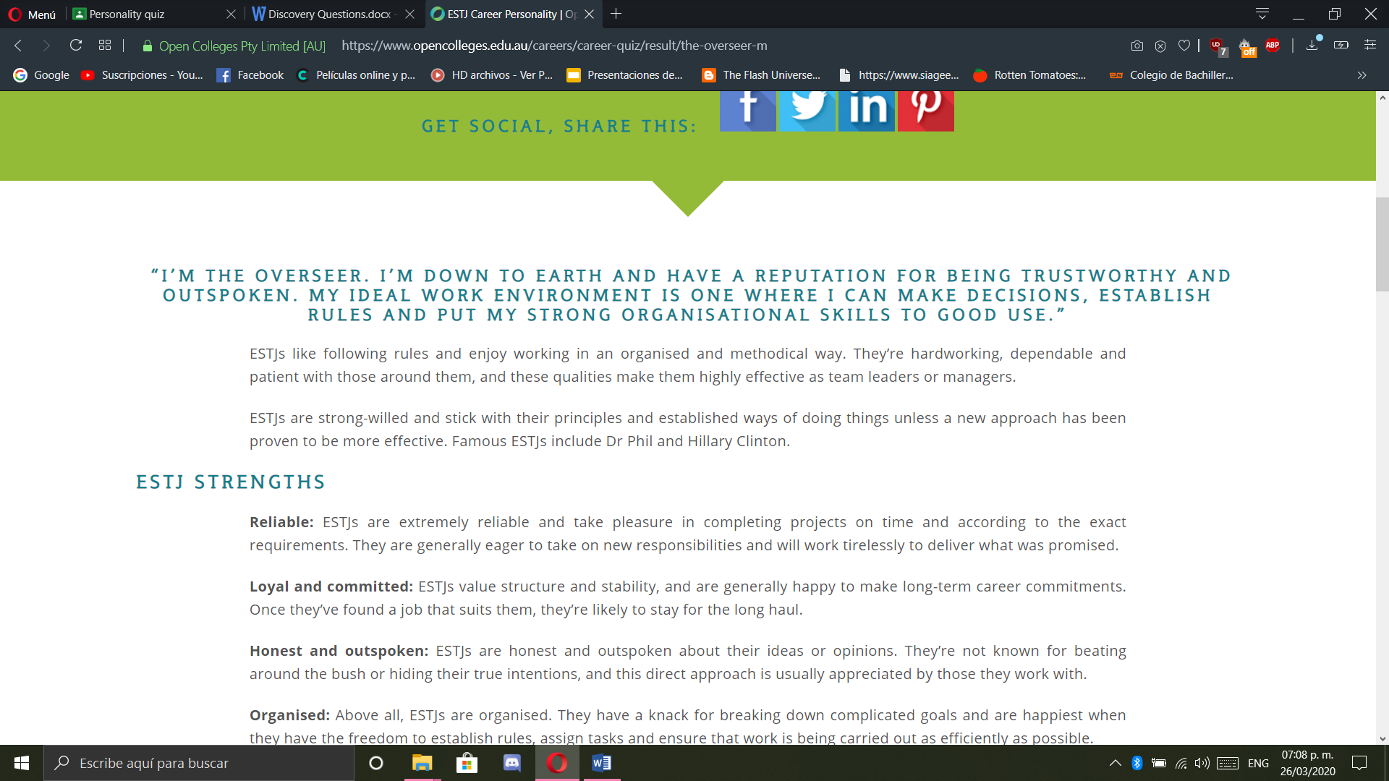

**STRENGTHS**

**Organised**

**Reliable**

**Strong-willed**

### WEAKNESSES

**Impassive**

**Self-conscious**

**Impassive**

### WHAT LOOK FOR IN A CAREER

**Clear hierarchy**

**Tangible results**

**Structure**

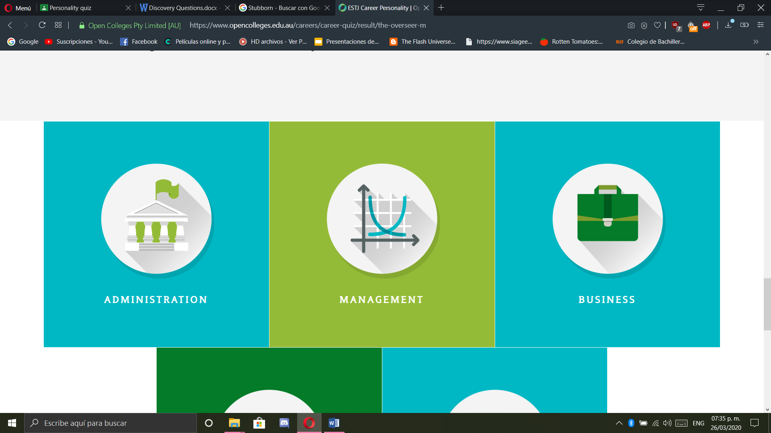

**Discovery Question.**

**Name:** Victor Manuel Galvan Covarrubias

Try to answer as clear as possible, please avoid vague answers.

1. What do you do that makes you feel invincible?

Knowing that I am the only me that exits and thinks in the way I do in the whole universe. No matter what happen in the future there is not going to be a person like.

1. What do people think you’re good at? If you don’t know, go ask them.

Resolving problems in a better and fast way that others. Also maintain all my things organized in the best possible way.

1. Who do you look up to? Who are your mentors? Who inspires you? Why?

Any CEO of a technology company that is changing our world. With the advances we can improve the way we live.

1. What has been your favorite class in University? Why did you like it?

Algebra because the processes and methods are always the same, the laws of mathematics do not change.

1. What social, political, environmental or other issues are important to you? How do you participate in these issues?

Climate changes is the only one that really matters because it means the future of our specie.

1. When was the last time you massively over-worked on something? What was it and why did you work so hard on it?

I have never really worked in something so hard, but the last thing I remember I worked a little hard was a project for an architecture class.

1. If you were able to be a member of the audience at your own funeral how would you want to be remembered?

Somebody that never stopped working a single day, somebody that always was looking for a self-improvement.

1. What is something you want to make sure to do in your lifetime?

Invent something, it can be anything like a device or a program, just to make sure that I made better the life of somebody.